**8-BIT ADDITION**

**EXP NO: 1**

**AIM:**

To write an assembly language program to implement 8-bit addition using 8085 processor.

**ALGORITHM:**  
1) Start the program by loading the first data into the accumulator.  
2) Move the data to a register.   
3) Get the second data and load it into the accumulator.  
4) Add the two register contents.   
5) Check for carry.  
6) Store the value of sum and carry in the memory location.   
7) Halt.   
  
**PROGRAM:**   
  
LDA 8500  
MOV B, A   
LDA 8501  
ADD B  
STA 8502  
RST 1  
  
**INPUT & OUTPUT:**  
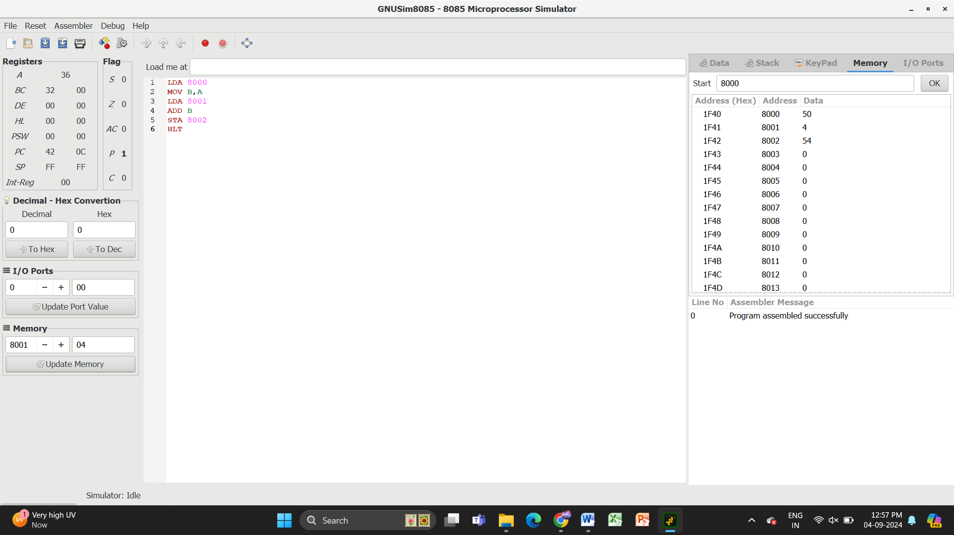

**RESULT:** Thus the program was executed successfully using 8085 processor simulator